***Simulating PWM Strategies***

***For***

***Power Electronics Converters***

***Buck Converter***

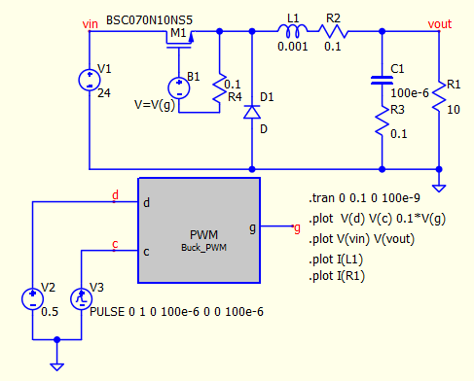

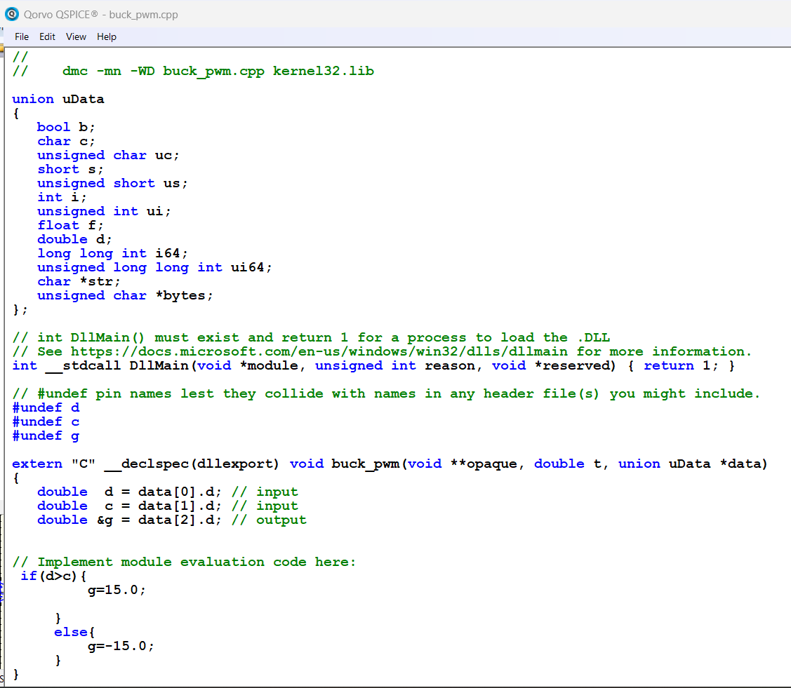

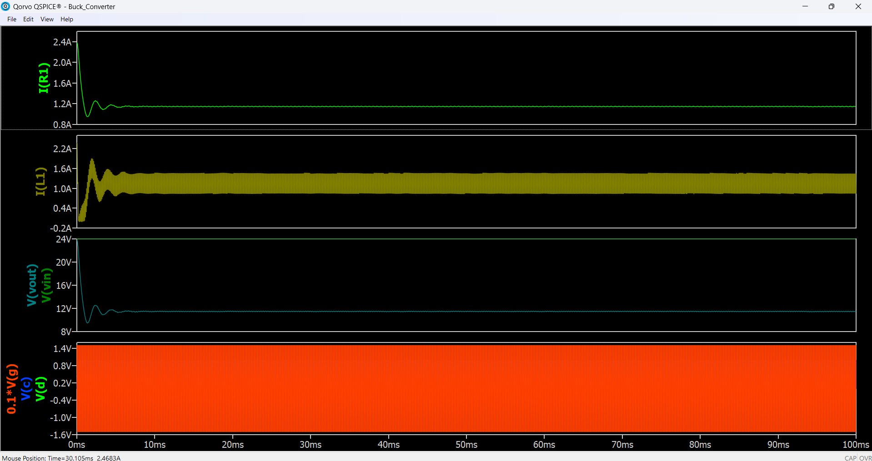

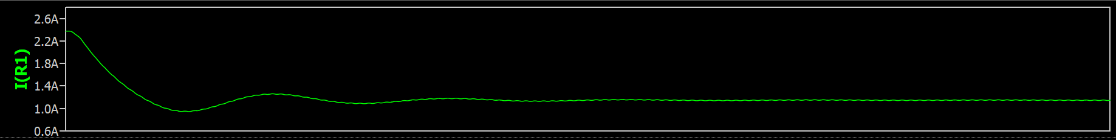

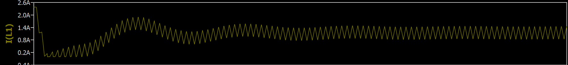

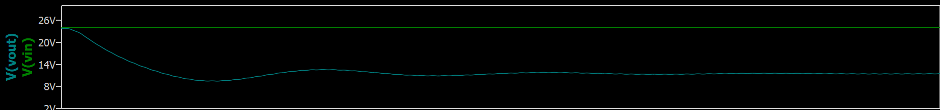

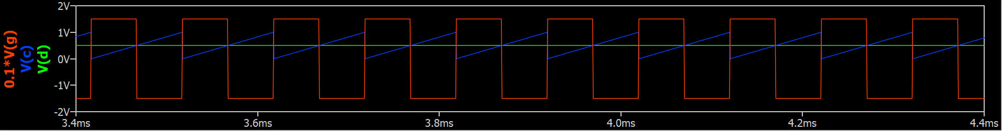

***BUCK BOOST CONVERTER***

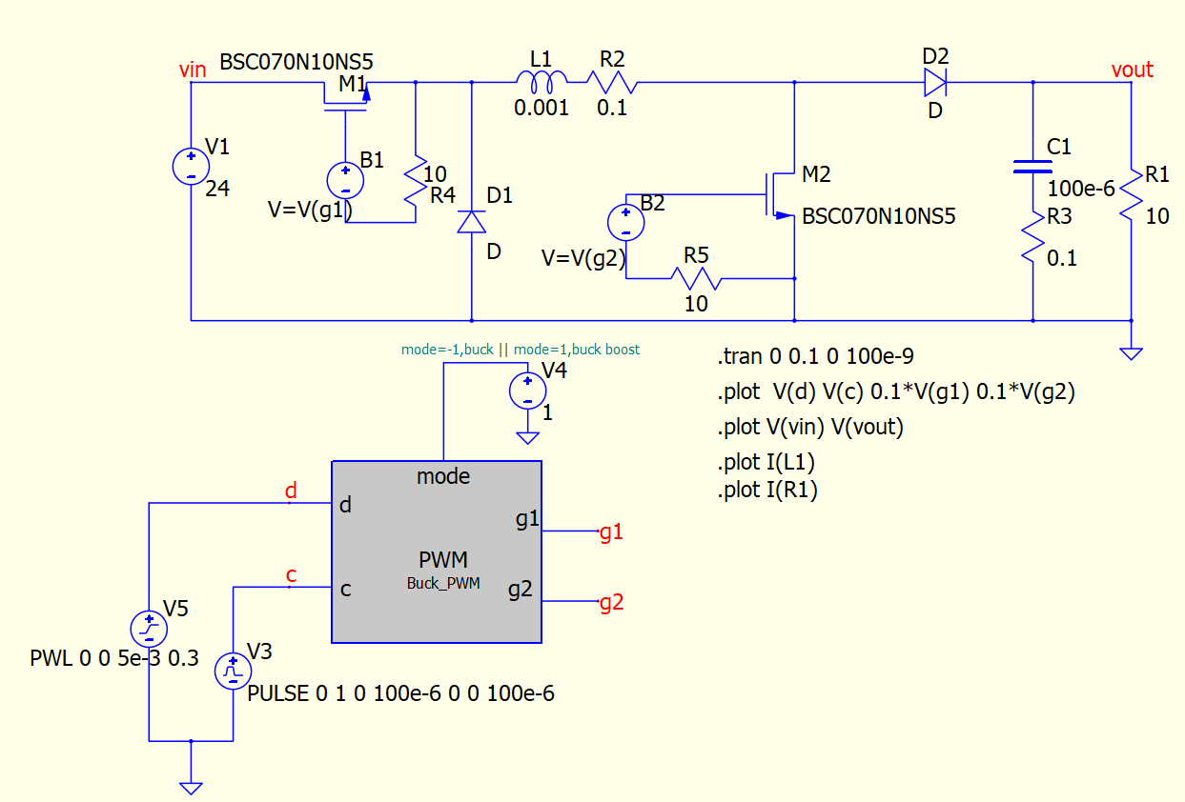

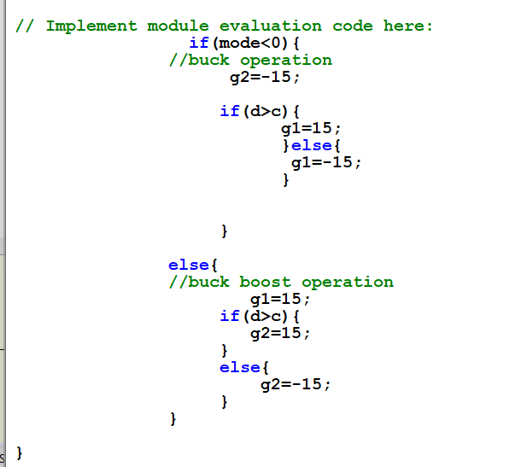

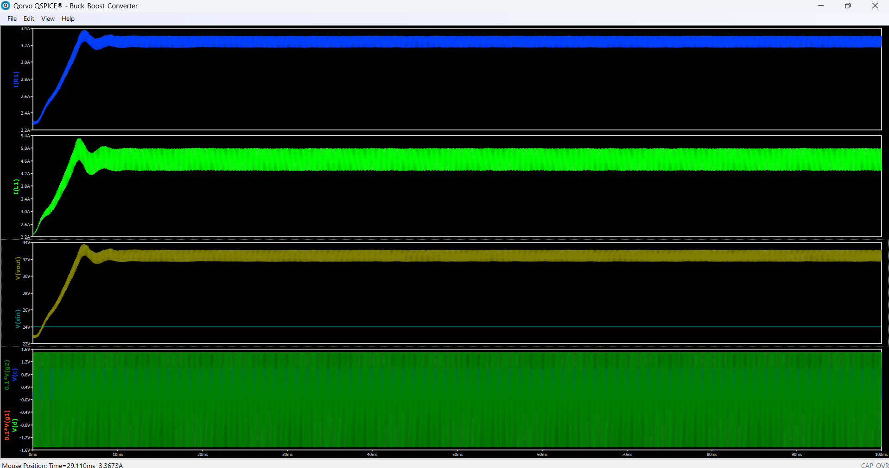

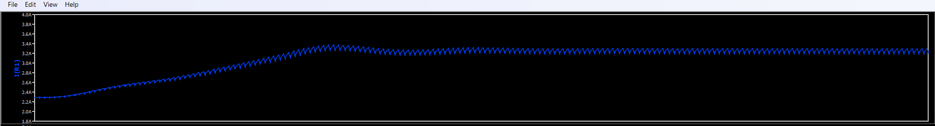

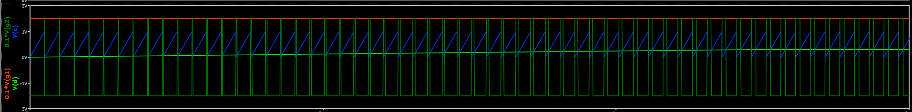

***BIDIRECTIONAL BUCK CONVERTER***

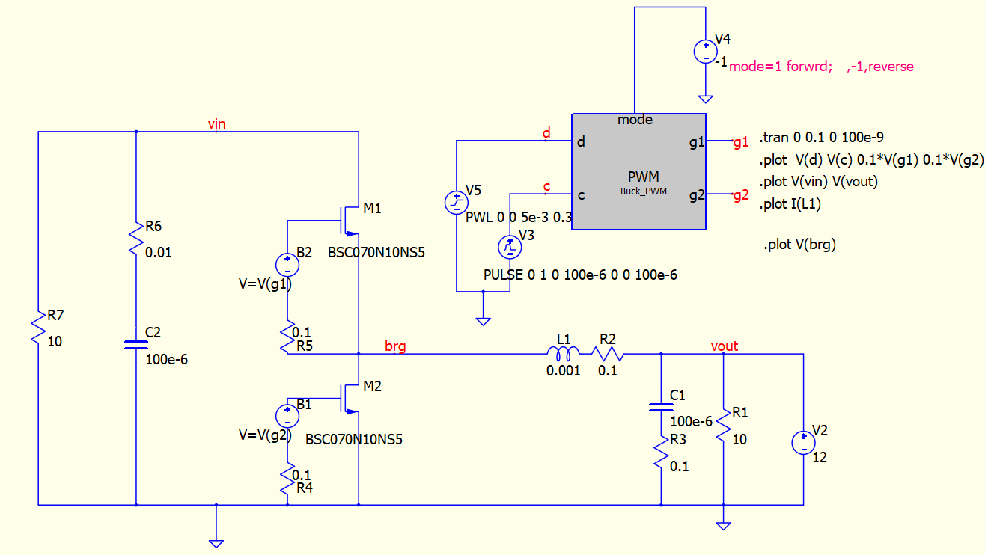

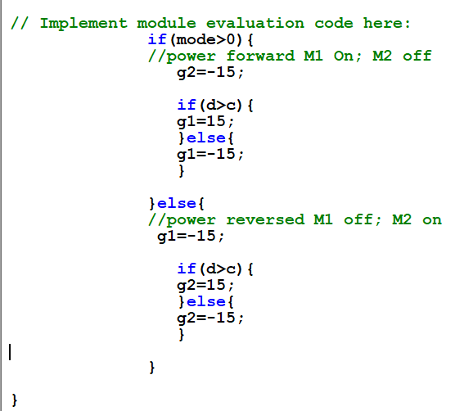

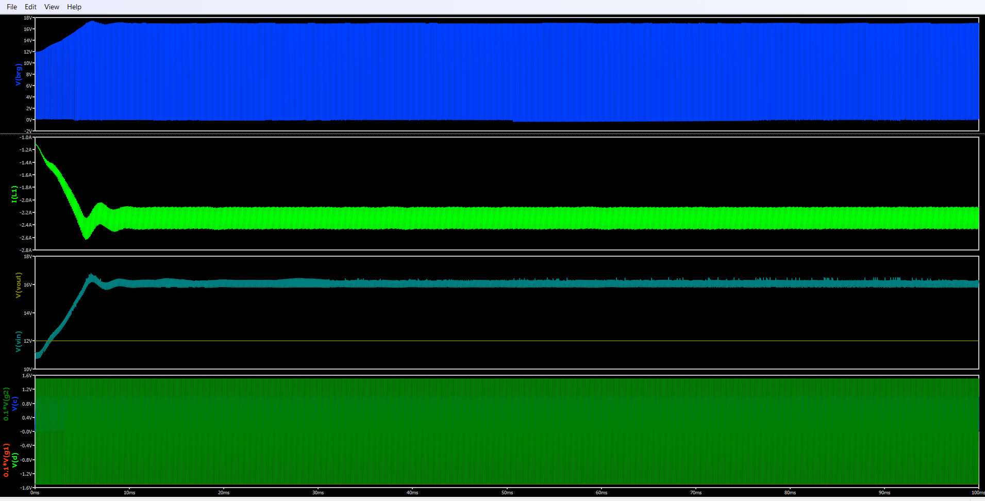

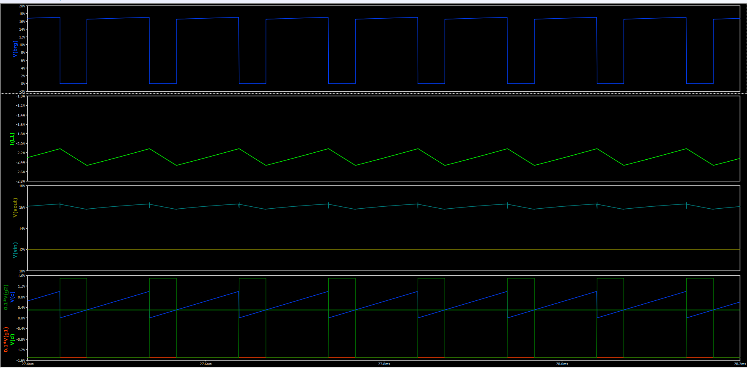

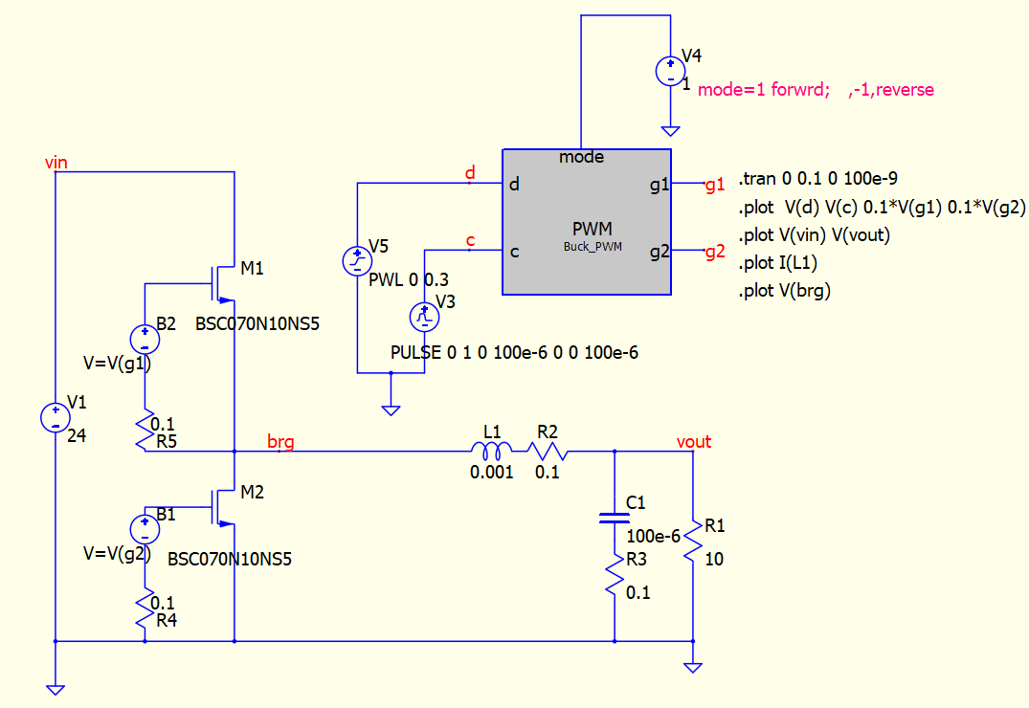

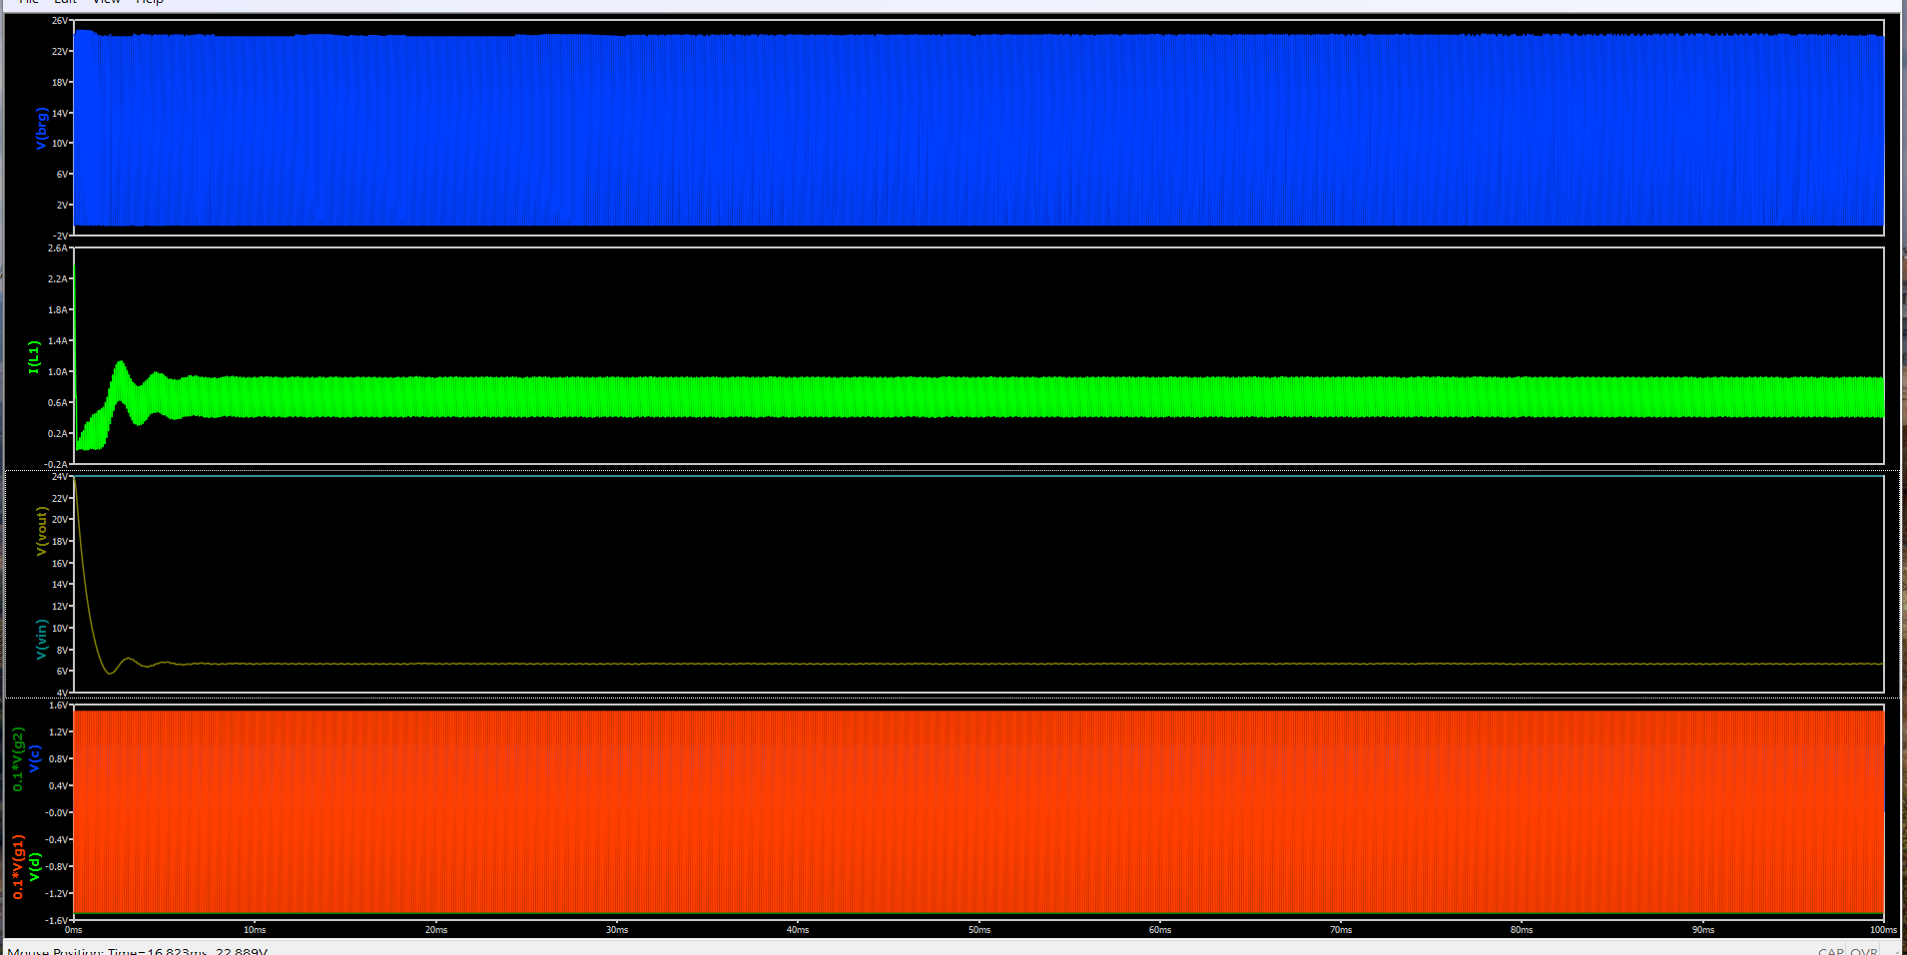

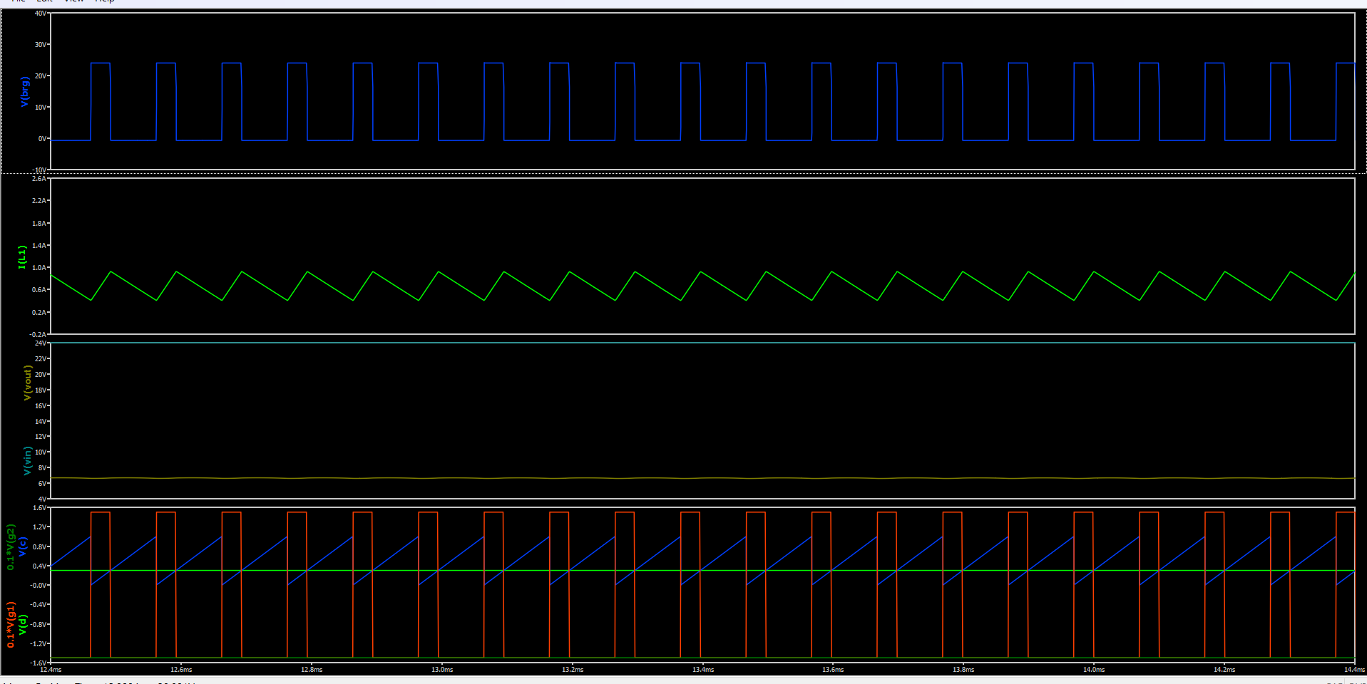

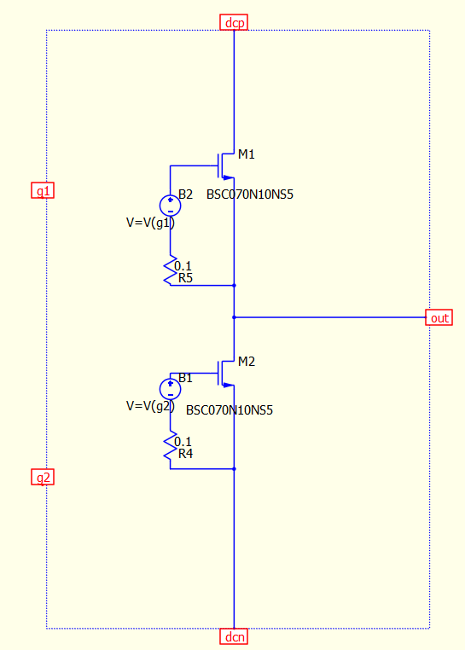

***BIDIRECTIONAL BUCK BOOST CONVERTER***

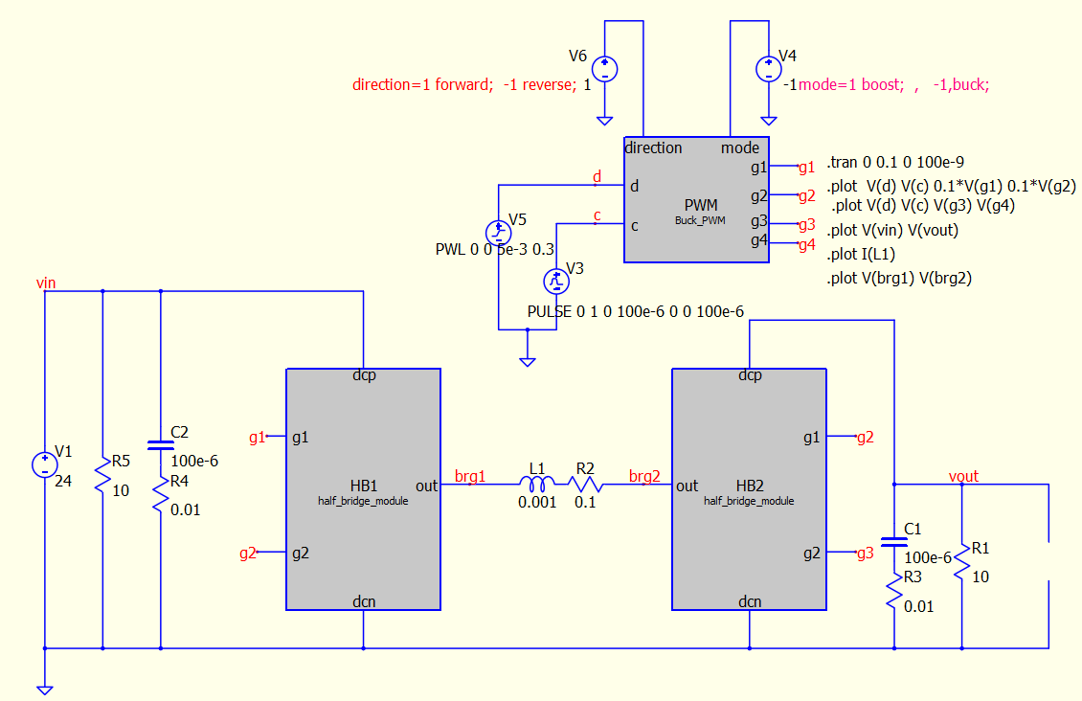

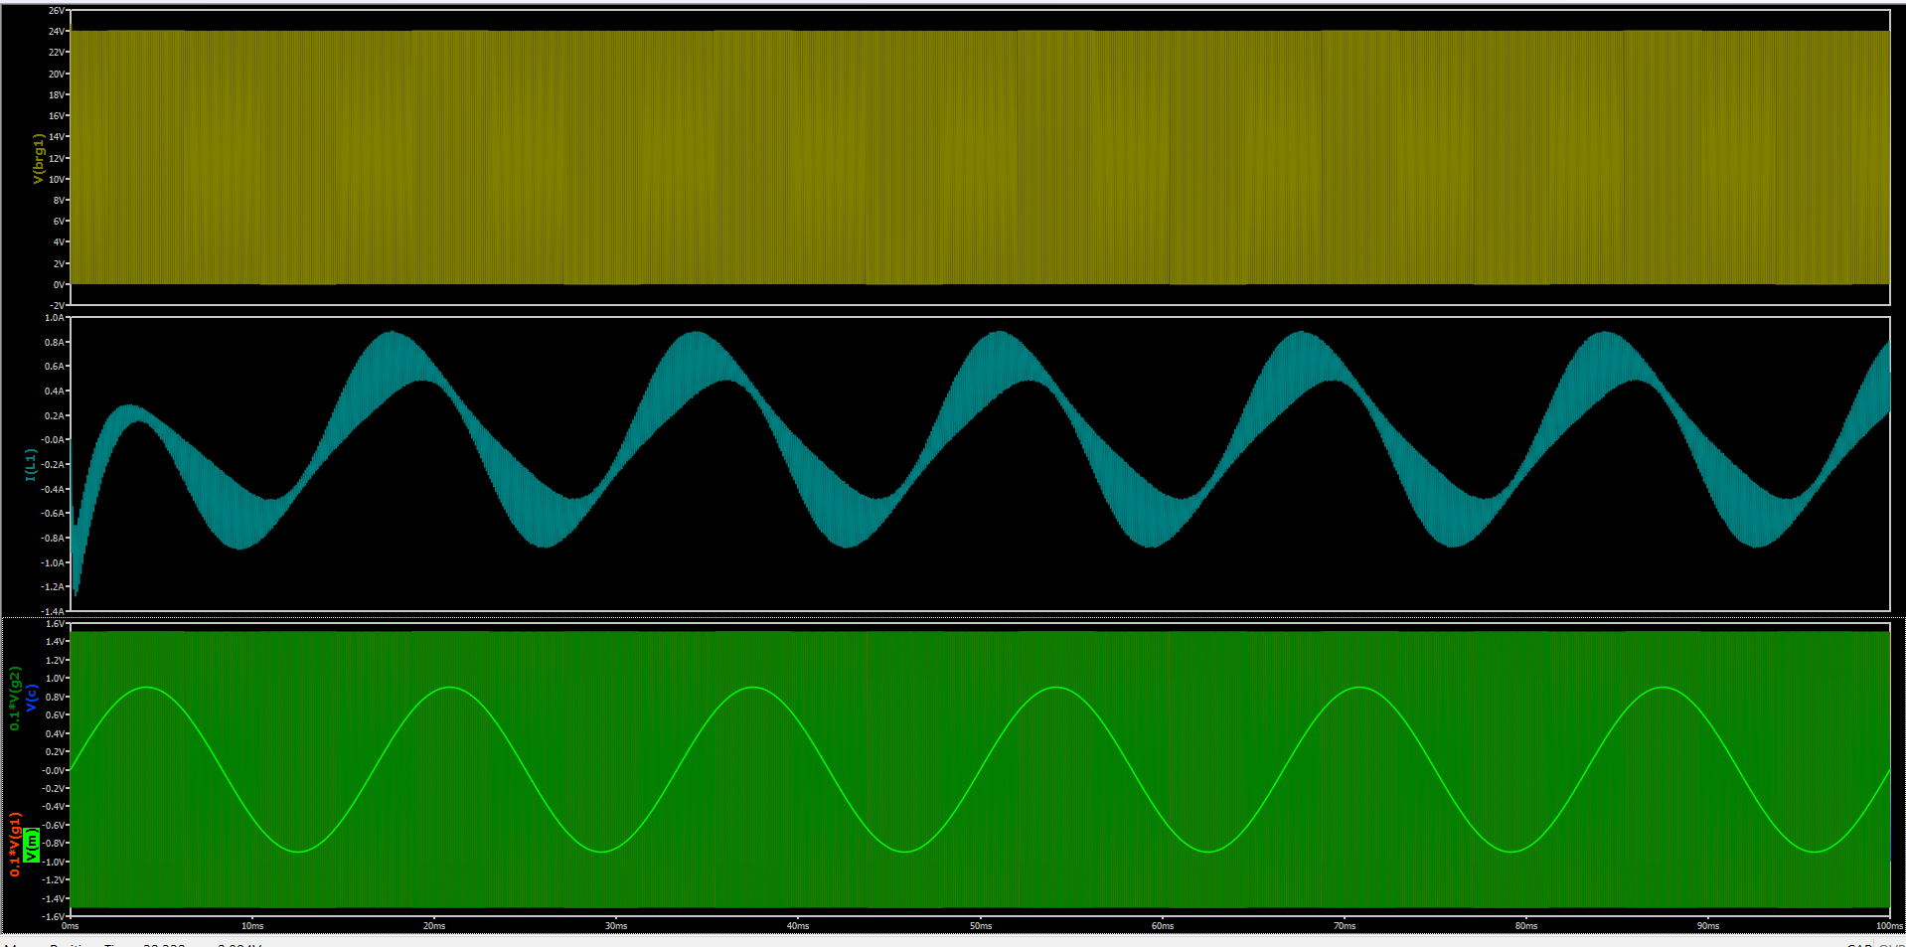

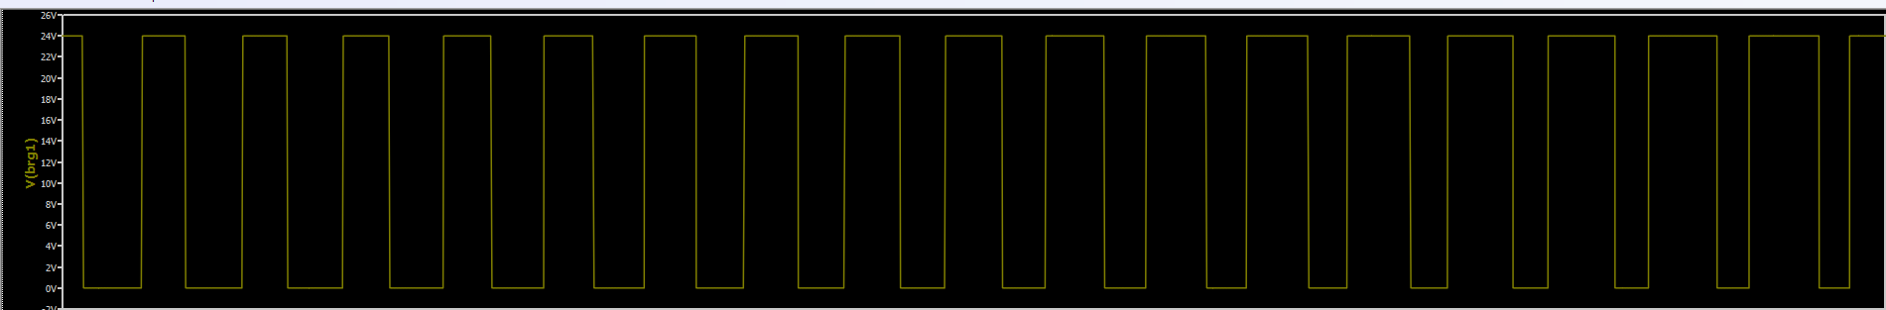

***FULL-BRIDGE DC-AC CONVERTER***

